APPLICATION FOR EMPLOYMENT

POSITION DESIRED: | WHEN CAN YOU REPORT? | SALARY DESIRED: | DATE OF APPLICATION:
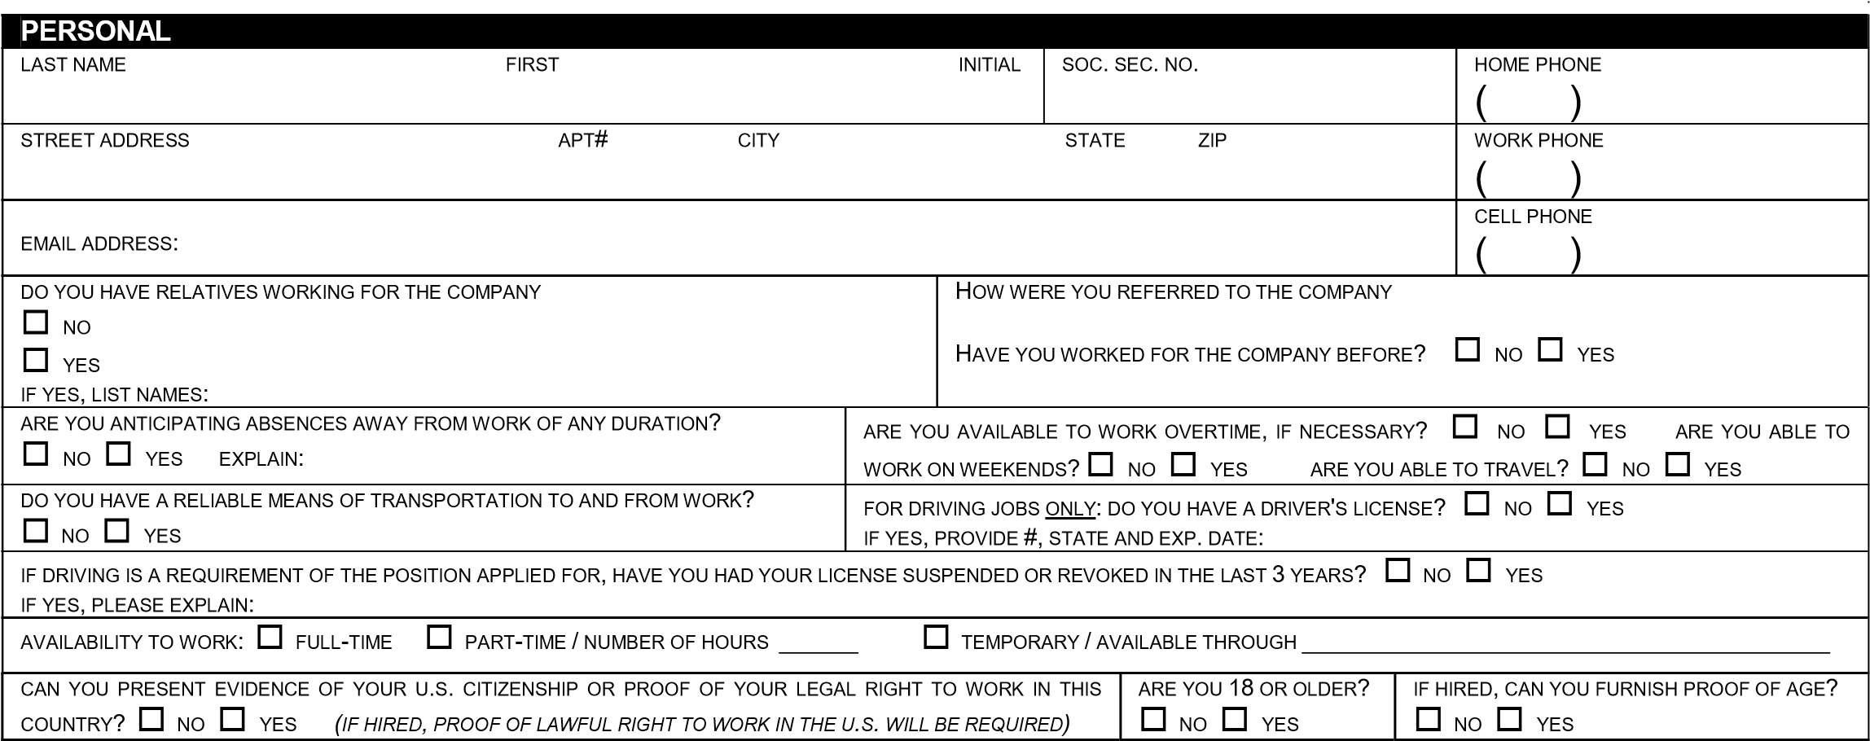
Please print in ink and answer all questions completely.
SCHOOL LOCATION |  |  |  | CIRCLE  GRADE/YEARS  COMPLETED |  |  |  |  |  |  |  | UNIT CREDITS |  | DEGREE EARNED |  |  | MAJOR
HIGH SCHOOL |  |  |  | 9 10 11 12 |  |  |  |  |  |  |  |  |  | GRADUATED  NO YES
JR. COLLEGE |  |  |  | 1 2
COLLEGE |  |  |  | 1 2 |  |  |  |  |  | 3 4
BUSINESS OR TRADE SCHOOL. LIST PROFESSIONAL DESIGNATIONS: |  |  |  | 1 2 |  |  |  |  |  | 3 4
MILITARY (To Be Completed By Both Male And Female)
HAVE YOU EVER SERVED IN THE UNITED STATES ARMED FORCES?  NO YES IF YES, BRANCH: | IF YES, GIVE DATES  FROM: TO: |  |  |  |  |  |  |  |  |  |  |  | FINAL RANK:
RELEVANT SKILLS ACQUIRED:
SKILLS (Check Any Of The Following Skills You Possess)
LIST ANY FOREIGN LANGUAGES YOU KNOW.  _____________________________  READ  WRITE  READ  WRITE  _____________________________ |  |  | SPEAK  SPEAK |  |  |  | OTHER APPLICABLE SKILLS - CHECK THOSE THAT APPLY:  OFFICE 2007 OFFICE 2003 GOLDMINE MAS 90 WINDOWS XP  WINDOWS VISTA QUICKBOOKS ORACLE PEOPLESOFT  OTHER
ADDITIONAL INFORMATION
HAVE YOU EVER BEEN CONVICTED OF A FELONY OR MISDEMEANOR? (CONVICTIONS FOR MARIJUANA-RELATED OFFENSES THAT ARE MORE THAN TWO YEARS OLD NEED NOT BE LISTED).
YES
NO
IF YES, EXPLAIN IN DETAIL AS TO TIME, NATURE, NUMBER AND DISPOSITION OF CONVICTION(S):
(NOTE: NO APPLICANT WILL BE DENIED EMPLOYMENT SOLELY ON THE GROUNDS OF CONVICTION OF A CRIMINAL OFFENSE. THE NATURE OF THE OFFENSE, THE DATE OF THE OFFENSE, THE SURROUNDING CIRCUMSTANCES AND THE RELEVANCE OF THE OFFENSE TO THE POSITION(S) APPLIED FOR MAY, HOWEVER, BE CONSIDERED.)
HAVE YOU USED ANY NAME OTHER THAN THE NAME YOU ARE CURRENTLY USING WHILE ATTENDING SCHOOL OR WITH A PREVIOUS EMPLOYER? NO YES IF YES, LIST NAME(S) YOU USED.
AS AN EMPLOYEE, HAVE YOU EVER BEEN INVOLUNTARILY DISCHARGED OR ASKED TO RESIGN? |  |  |  |  |  |  |  | NO |  |  | YES
HAVE YOU EVER BEEN BONDED? NO YES HAVE YOU EVER BEEN REFUSED BONDING? NO YES
IF YES, WHAT TYPE AND REASON:
IF REQUIRED, WILL YOU UNDERGO A PRE-EMPLOYMENT PHYSICAL OR DRUG TEST? |  |  | NO |  |  | YES
ARE YOU ABLE TO PERFORM THE ESSENTIAL FUNCTIONS OF THE JOB WHICH YOU ARE APPLYING, EITHER WITH OR WITHOUT REASONABLE ACCOMMODATION? THE FUNCTIONS THAT CANNOT BE PERFORMED:  (NOTE: WE COMPLY WITH THE ADA AND CONSIDER REASONABLE ACCOMODATION MEASURES THAT MAY BE NECESSARY FOR ELIGIBLE APPLICANTS/EMPLOYEES TO PERFORM ESSENTIAL FUNCTIONS.  SKILL AND AGILITY TESTS.) |  |  |  |  |  |  |  |  |  |  |  |  |  |  |  | NO  HIRE MAY BE SUBJECT TO PASSING A MEDICAL EXAMINATION |  |  | YES IF NO, DESCRIBE  , AND
Page 1 of 2
AN AFFIRMATIVE ANSWER TO ANY OF THESE QUESTIONS MAY NOT NECESSARILY DISQUALIFY YOU FROM CONSIDERATION FOR EMPLOYMENT.
EMPLOYMENT HISTORY
LIST ALL EMPLOYMENT FOR THE PAST 10 YEARS, INCLUDING MILITARY SERVICE AND PERIODS OF UNEMPLOYMENT. FOR ADDITIONAL EMPLOYMENT HISTORY OR EXPLANATIONS, USE THE SUPPLEMENTAL APPLICATION FOR EMPLOYMENT. YOU MUST COMPLETE THIS SECTION EVEN IF ATTACHING A RESUME.
FIRM (please start with most recent position) (may we contact? |  | No |  | Yes) | TITLE AND SUMMARY OF YOUR DUTIES:
ADDRESS CITY STATE ZIP
SUPERVISOR PHONE
DATES OF EMPLOYMENT (include month and year) BASE SALARY  From: To: Starting $ Ending $ |  |  |  |  | FULL-TIME  PART-TIME |  | REASON FOR LEAVING:
FIRM (may we contact? |  | No |  | Yes) | TITLE AND SUMMARY OF YOUR DUTIES:
ADDRESS CITY STATE ZIP
SUPERVISOR PHONE
DATES OF EMPLOYMENT (include month and year) BASE SALARY  From: To: Starting $ Ending $ |  |  |  |  | FULL-TIME  PART-TIME |  | REASON FOR LEAVING:
FIRM (may we contact? |  | No |  | Yes) | TITLE AND SUMMARY OF YOUR DUTIES:
ADDRESS CITY STATE ZIP
SUPERVISOR PHONE
DATES OF EMPLOYMENT (include month and year) BASE SALARY  From: To: Starting $ Ending $ |  |  |  |  | FULL-TIME REASON FOR LEAVING:  PART-TIME
REFERENCES
LIST BELOW THREE PERSONS NOT RELATED TO YOU WHO HAVE KNOWLEDGE OF YOUR WORK PERFORMANCE WITHIN THE LAST THREE YEARS.
NAME AND OCCUPATION ADDRESS TELEPHONE # YEARS KNOWN

__________________________________________________________________________________________________________________________________________

I N I T I A L A F F I D A V I T
______ | I certify that all information provided in this employment application and supplementary application are true and complete. I agree to have any of the statements checked by the company unless indicated to the contrary. I understand that any false information or omission may disqualify me from further consideration for employment and may result in my dismissal if discovered at a later date.
______ | I am aware that a more detailed investigation concerning background and credit may also be conducted, I hereby authorize that investigation. I also understand that employment is contingent upon satisfactory completion of reference checks and the provision of satisfactory proof of an applicant’s identity and legal authority to work in the United States.
______ | I understand that if I am extended an offer of employment, it may be conditioned upon my successfully passing a pre-employment alcohol and drug screening examination. I understand that my job offer or my continuing employment, if hired, is contingent upon my being physically, mentally and medically able, with or without reasonable accommodation, to successfully perform the essential functions of my job. I consent to the release of any or all medical information as may be deemed necessary to judge my capability to do the work for which I am applying.
______ | I understand that nothing in this application, conveyed during any interview, or subsequent employment creates a contract of employment between the company or any subsidiary or affiliate and myself, nor guarantees employment for any definite period of time. If employed, I understand that I have been hired at the will of the employer and my employment may be terminated at any time, with or without cause or notice by either myself or the company. I understand that the company can change benefits, policies and conditions at any time.
______ | I understand that any and all disputes regarding my employment with the company, including any disputes relating to the termination of my employment, are subject to the Alternative Dispute Resolution process, which includes final and binding arbitration. I also understand and agree, as a condition of employment, to submit any such disputes for resolution under that process, and I further agree to abide by and accept the decision of the arbitration panel as the final binding decision and resolution of any such disputes I may have.
PLEASE READ EACH STATEMENT CAREFULLY BEFORE SIGNING. I have read, understand, and by my signature consent to these statements.
APPLICANT'S SIGNATURE: DATE:
Page 2 of 2

